Name: _____________________________________________ Date: ____________ Period: ___
Understanding Satire Note-taking Guide
Modest Proposal Unit

Directions: As you listen and view the presentation, complete the note-taking guide. It is also available on the class website, www.mrsguillory.weebly.com. Click on Curriculum Units & Resources > on submenu, click Satire/A Modest Proposal > scroll down until you see Understanding Satire Presentation. It is the second presentation under the picture of the Simpsons. Or, you can scan the QR code to be directed to the webpage.

What is Satire?
- Definition: The use of humor to attack or ridicule something (such as a person, habit, idea, institution, society, or custom) that is considered (thought to) be foolish (silly), flawed, or wrong
- Goal of Satire: _______________________________________________________________________________
- Attempts through _______________ and ________________ to inspire individuals, institutions, and humankind to improve
- Simple Definition: Making fun of something/someone in order to ______________________________________

Satirical “Advertisement” Analysis
Review the McDonald’s ad. Respond to the following questions based on what you read and see.
- What or who is the subject of the ad?

- What comment is the ad making about society, or about people who choose to eat
at McDonalds?

Satirical Techniques

- Hyperbole
  - Also known as __________________________
  - Definition: to enlarge, to increase, to represent something beyond _________________ bounds so that it becomes ____________________ and its _________________ can be seen
  - Caricature: exaggerating of __________________________________
- Parody
  - Definition: to ________________ the techniques and/or style of some ________________, place, or thing in order to ridicule (or make fun) of the original

- Reversal
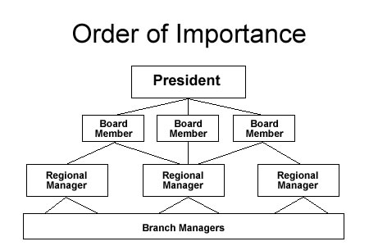
  - Definition: to present the ___________________ of the _______________ order
  - It can focus on: __________________________ or hierarchical order

- Oxymoron
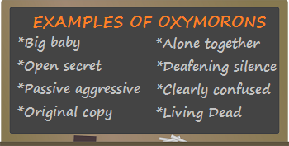
  - Also known as: __________________________
  - Definition: to present things that are out of ______________ or are ____________________, illogical, or inappropriate in relation to its ______________________________
- Other types of Satirical Techniques
  - Creating a ridiculous or funny list of or about something
  - Silly or ____________ words
  - ________________, which is a form of _____________________________
  - Understatement: the writer shows less ______________________ or passion for a particular subject that would seem to demand more ____________________
  - Pun: a play on words for a ______________________ effect
    - Example: A single leaf tells a person, “Leaf me alone. I’m busy.”
What do Satirists Attack?
Other Vices
NOTE: a vice is immoral or wicket behavior
- Stupidity
- Poor decision making
- _____________________
- Self-centeredness (arrogance/conceit)
- Corruption
- _______________________
- _______________________
- Dishonesty
7 Deadly Sins
- Pride
- ______________
- ______________
- Laziness
- Lust
- Jealousy
- _______________

Assignment: Analyzing Satire (This section is best completed with a partner)
You will analyze satirical ads to determine:
- The subject of the satire
- The comment the satire is making
- The technique(s) the satire uses to make its point

Directions:
- First, you’ll see the original advertisement
- Second, you’ll see the satire of the advertisement or the company
- Write:
  - The subject matter of the satire
  - The comment the satire is trying to communicate
  - List all of the technique(s) used to satirize:
    - From the list you create, select ONLY ONE technique and explain the satire being used
  - Briefly explain (2-3 sentences) why you think the advertisement is either effective or not effective? Meaning, is the advertisement satire strong enough to persuade some people, or to make them think about the subject matter and change their views on it? Why or why not?

