Name _____________________________ Date: __________ Period: ____

Mind Your Manners!
Pride and Prejudice Connection Warm-up
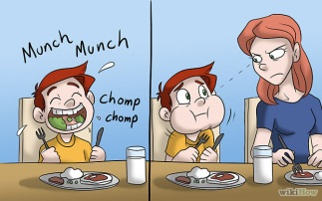

- What are manners?

- Is etiquette the same as manners? Explain.

- How are manners often sexist?

- When can manners be snobbish?

- List 5 reasons why manners can be good for you.

___________________________________

___________________________________

___________________________________

___________________________________

___________________________________

6. AGREE/DISAGREE with this statement: “If someone is rude to me, it’s okay to be rude to them.” Briefly explain your answer in 2-3 sentences.

