Name: ________________________________ Date: __________ Period: ____
Pride and Prejudice
Viewing Comprehension Questions
PART 4
(Starting at 1:08:00)

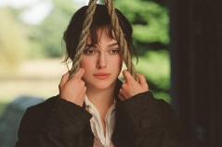

Directions: As you view the movie version of Jane Austen’s classic, Pride and Prejudice, answer the following questions. It is not required for you to answer in complete sentences.

**You need to answer these on your OWN sheet of paper. DO NOT write your answers here, because I will give it right back to you to re-write on paper. You may also type your responses and email them to: shakira.guillory@fortbendisd.com.

- What does Mr. Darcy confess to Elizabeth?
- What does he ask of her?
- What is the reason Darcy gives for separating Mr. Bingley and Jane?
- During their argument, what reason does Elizabeth give to Mr. Darcy about why she refuses to marry him?
- Explain the specifics as to why Mr. Darcy does not like Mr. Wickham.
- Does Mr. Darcy truly believe he was trying to help Mr. Bingley when he suggested that Mr. Bingley not marry Jane?
- Why doesn’t Elizabeth want Lydia to go on vacation with the Foresters?
- Who has invited Elizabeth, her aunt, and her uncle to dinner? For what reason?
- What news does Elizabeth receive about Lydia?
- Where is Mr. Darcy going?

